Software Development Unit 33, 3.5

Anna Legaspi

# I can demonstrate a working development project and describe the main features

Following my recent collaborative project with the other learners, we have been able to complete a website that has all of our individual webpages. You’ll be able to see the final product and the journey in developing this within Unit 33, 2.1-2.2. In this unit, I will demonstrate the final product and describe its main features.

## Website Diagram and Structure

Within the main website, you can see wire diagram requirements for basic website: Header, Navigation, Body and Footer.

* Header – confirms what the website is about
* Navigation – Links to each of the team members webpages
* Body – Has the team member’s web page content
* Footer – Has the team member’s names, project title and any copyright information

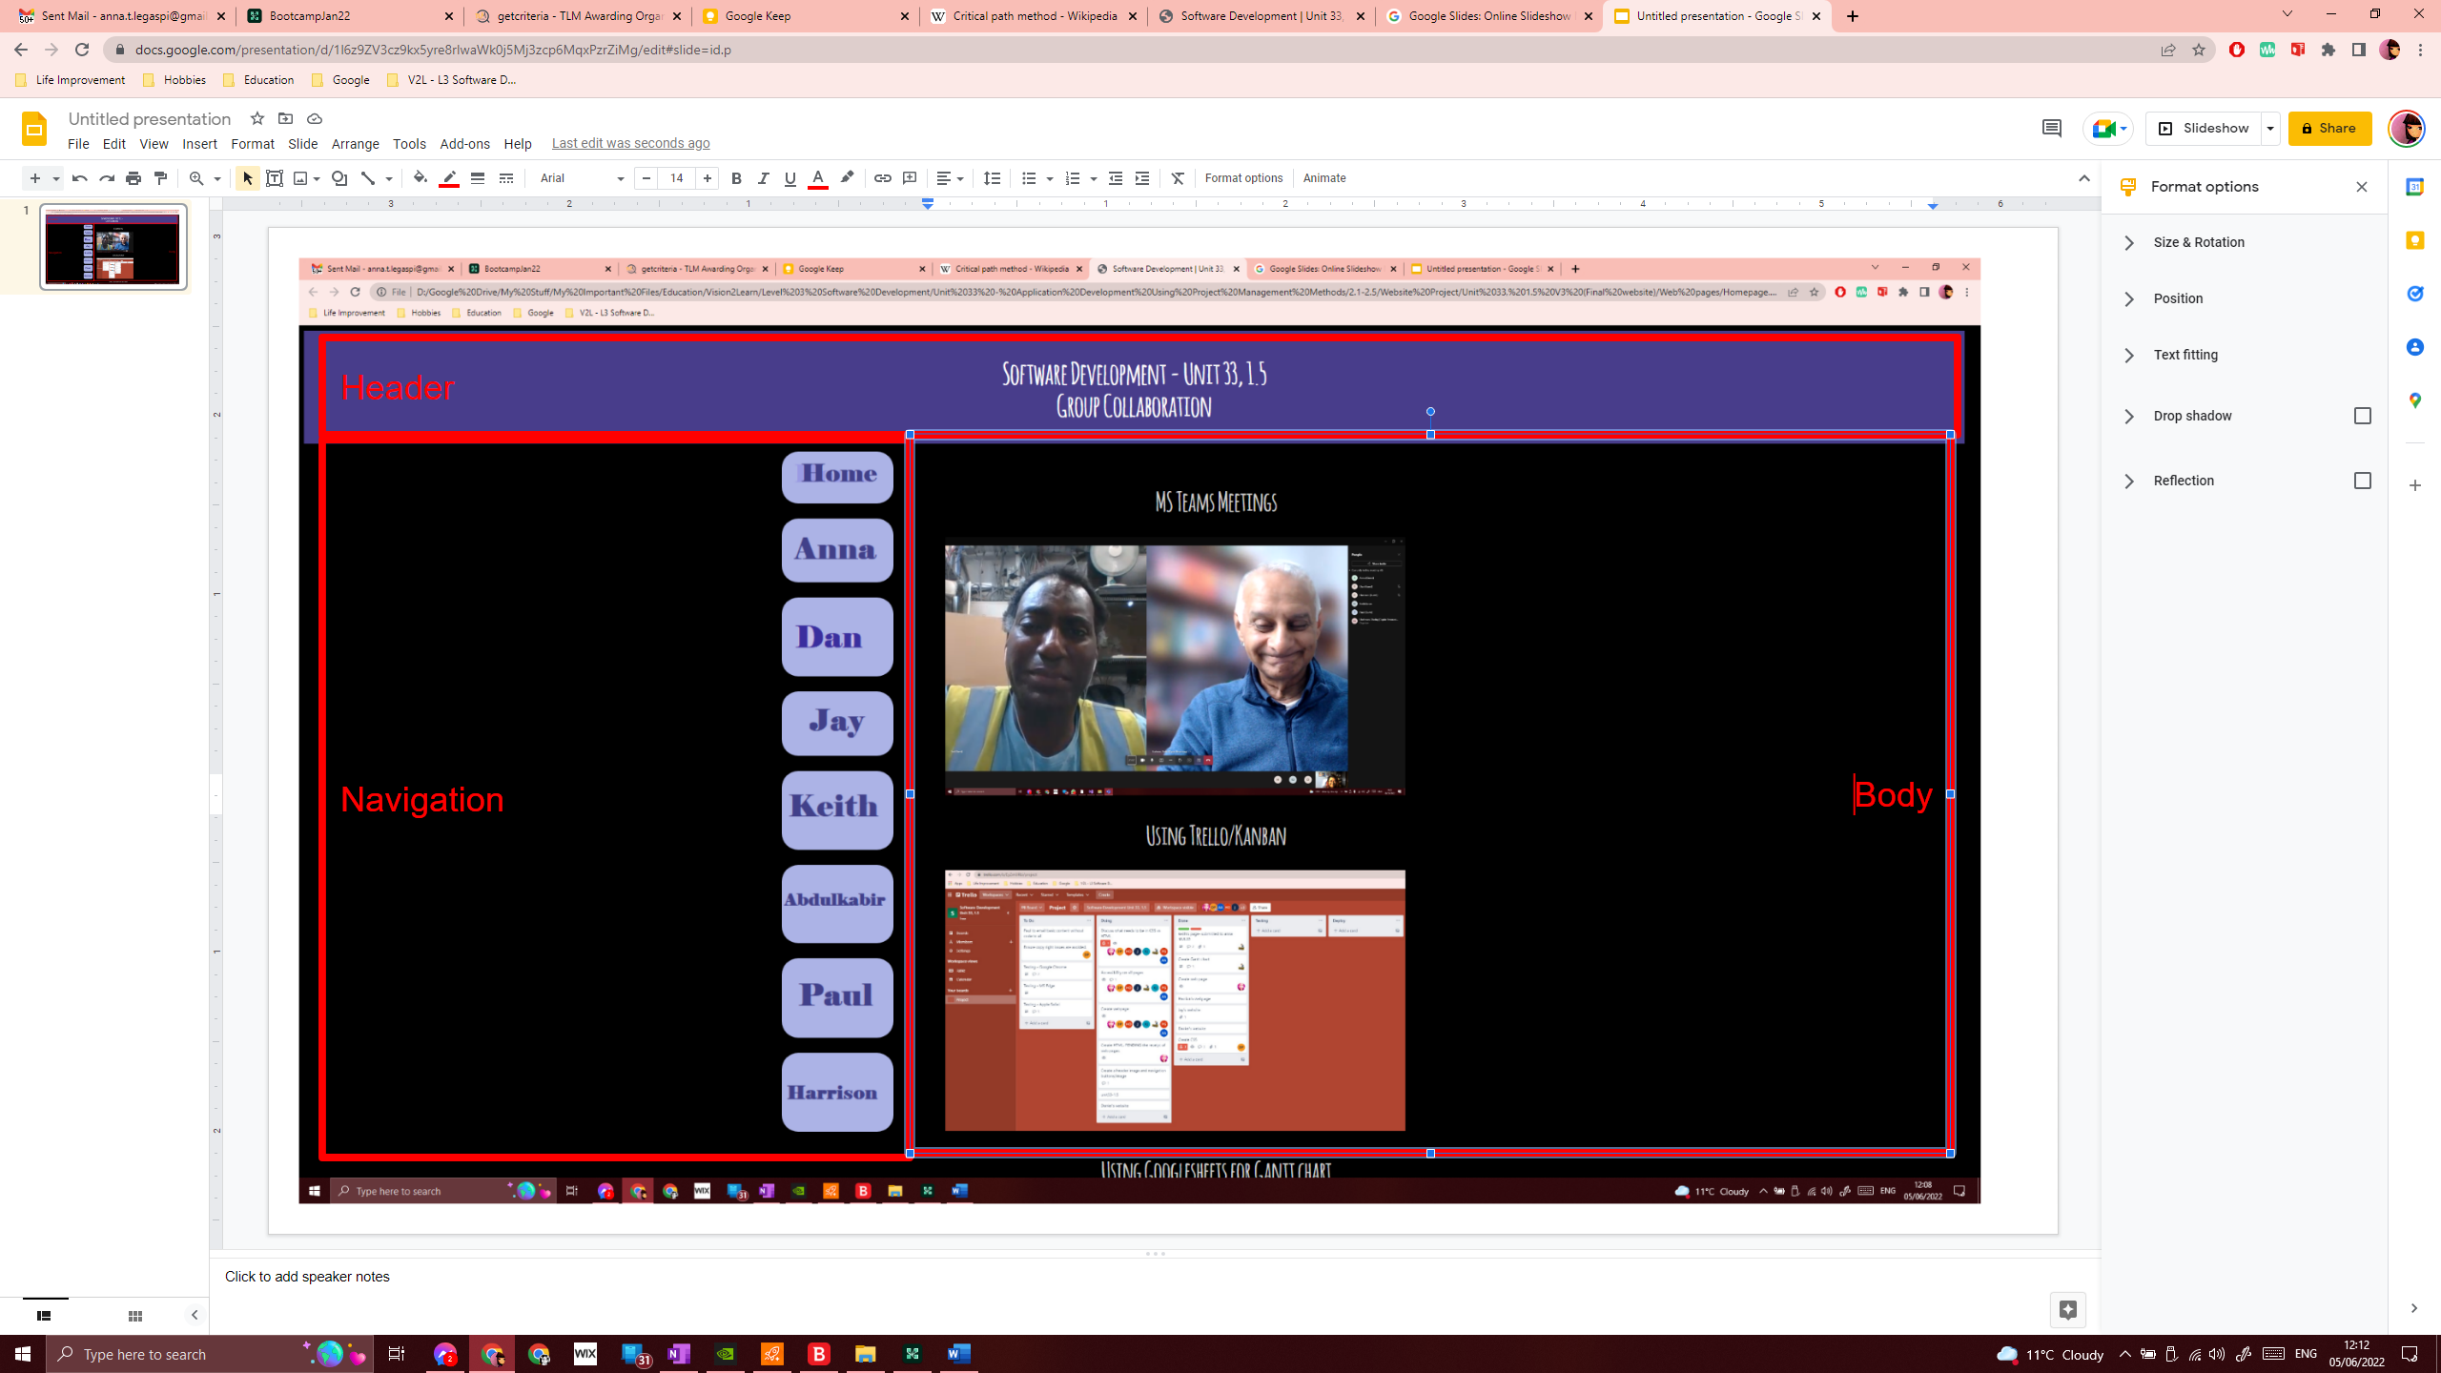

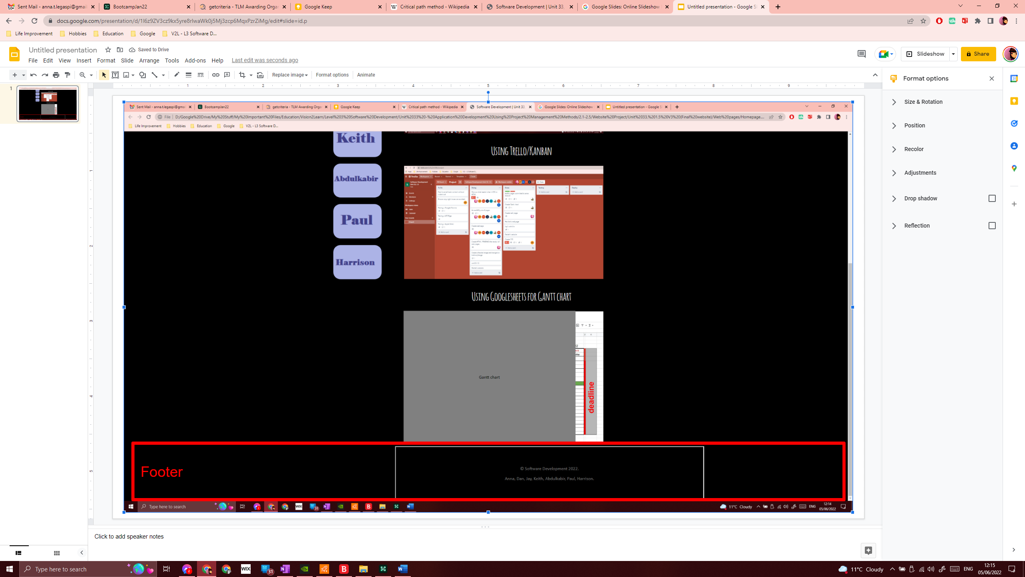

## Navigation and individual web pages

The navigation has all of the team member’s names and the home page. When a specific member’s navigation button is selected, the user of the website is taken to the relevant webpage. The content is created by each team member is simple yet effective. Issues were unfortunately encountered when making amendments to the CSS. This would be sorted in the next ‘sprint’ if given the opportunity.

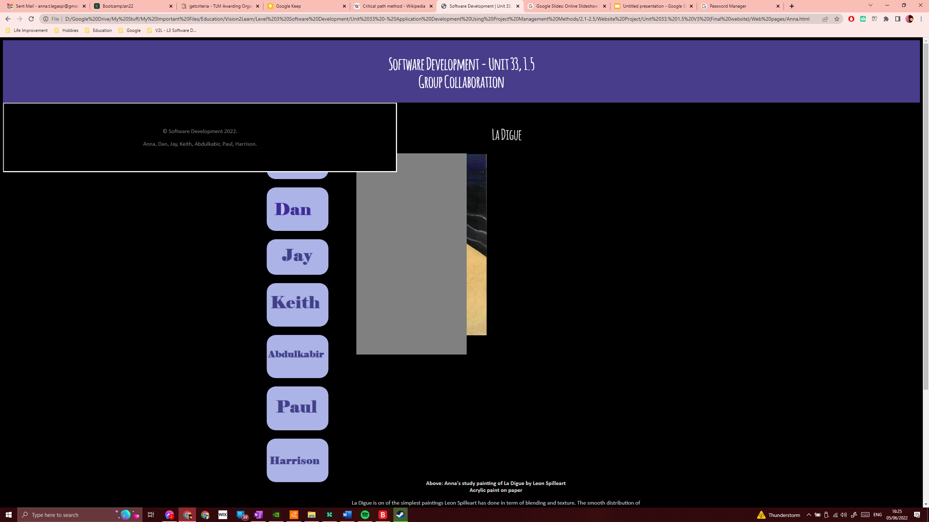

Figure 1Anna's page

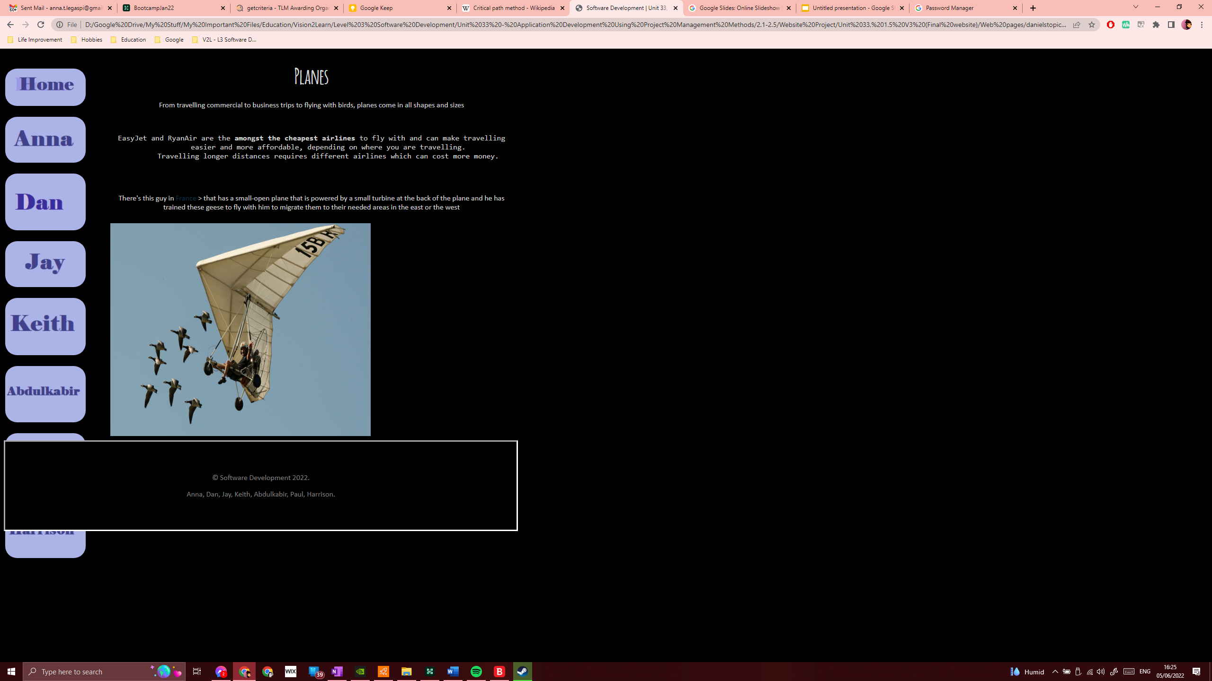

Figure 2 Dan's page

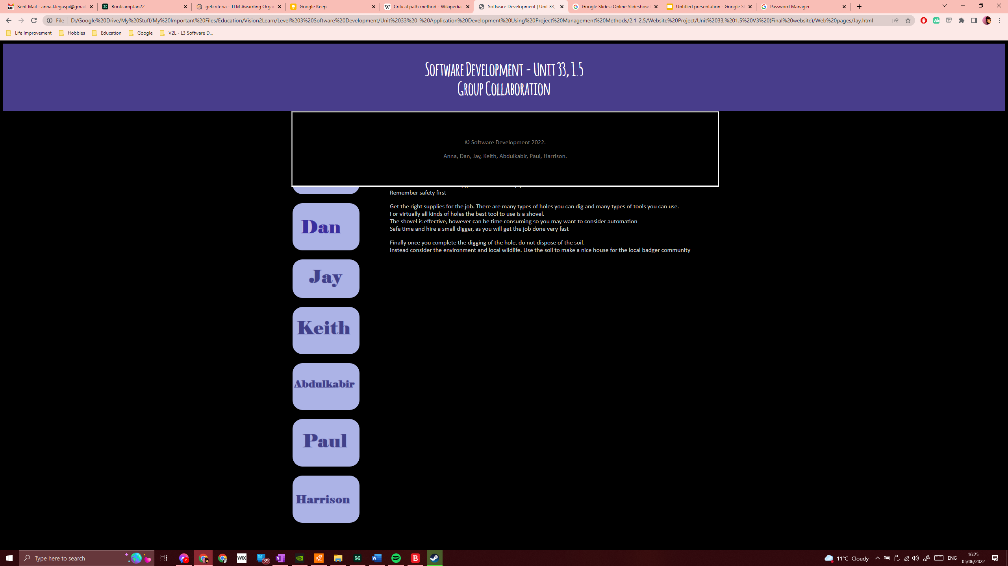

Figure 3 Jay's page

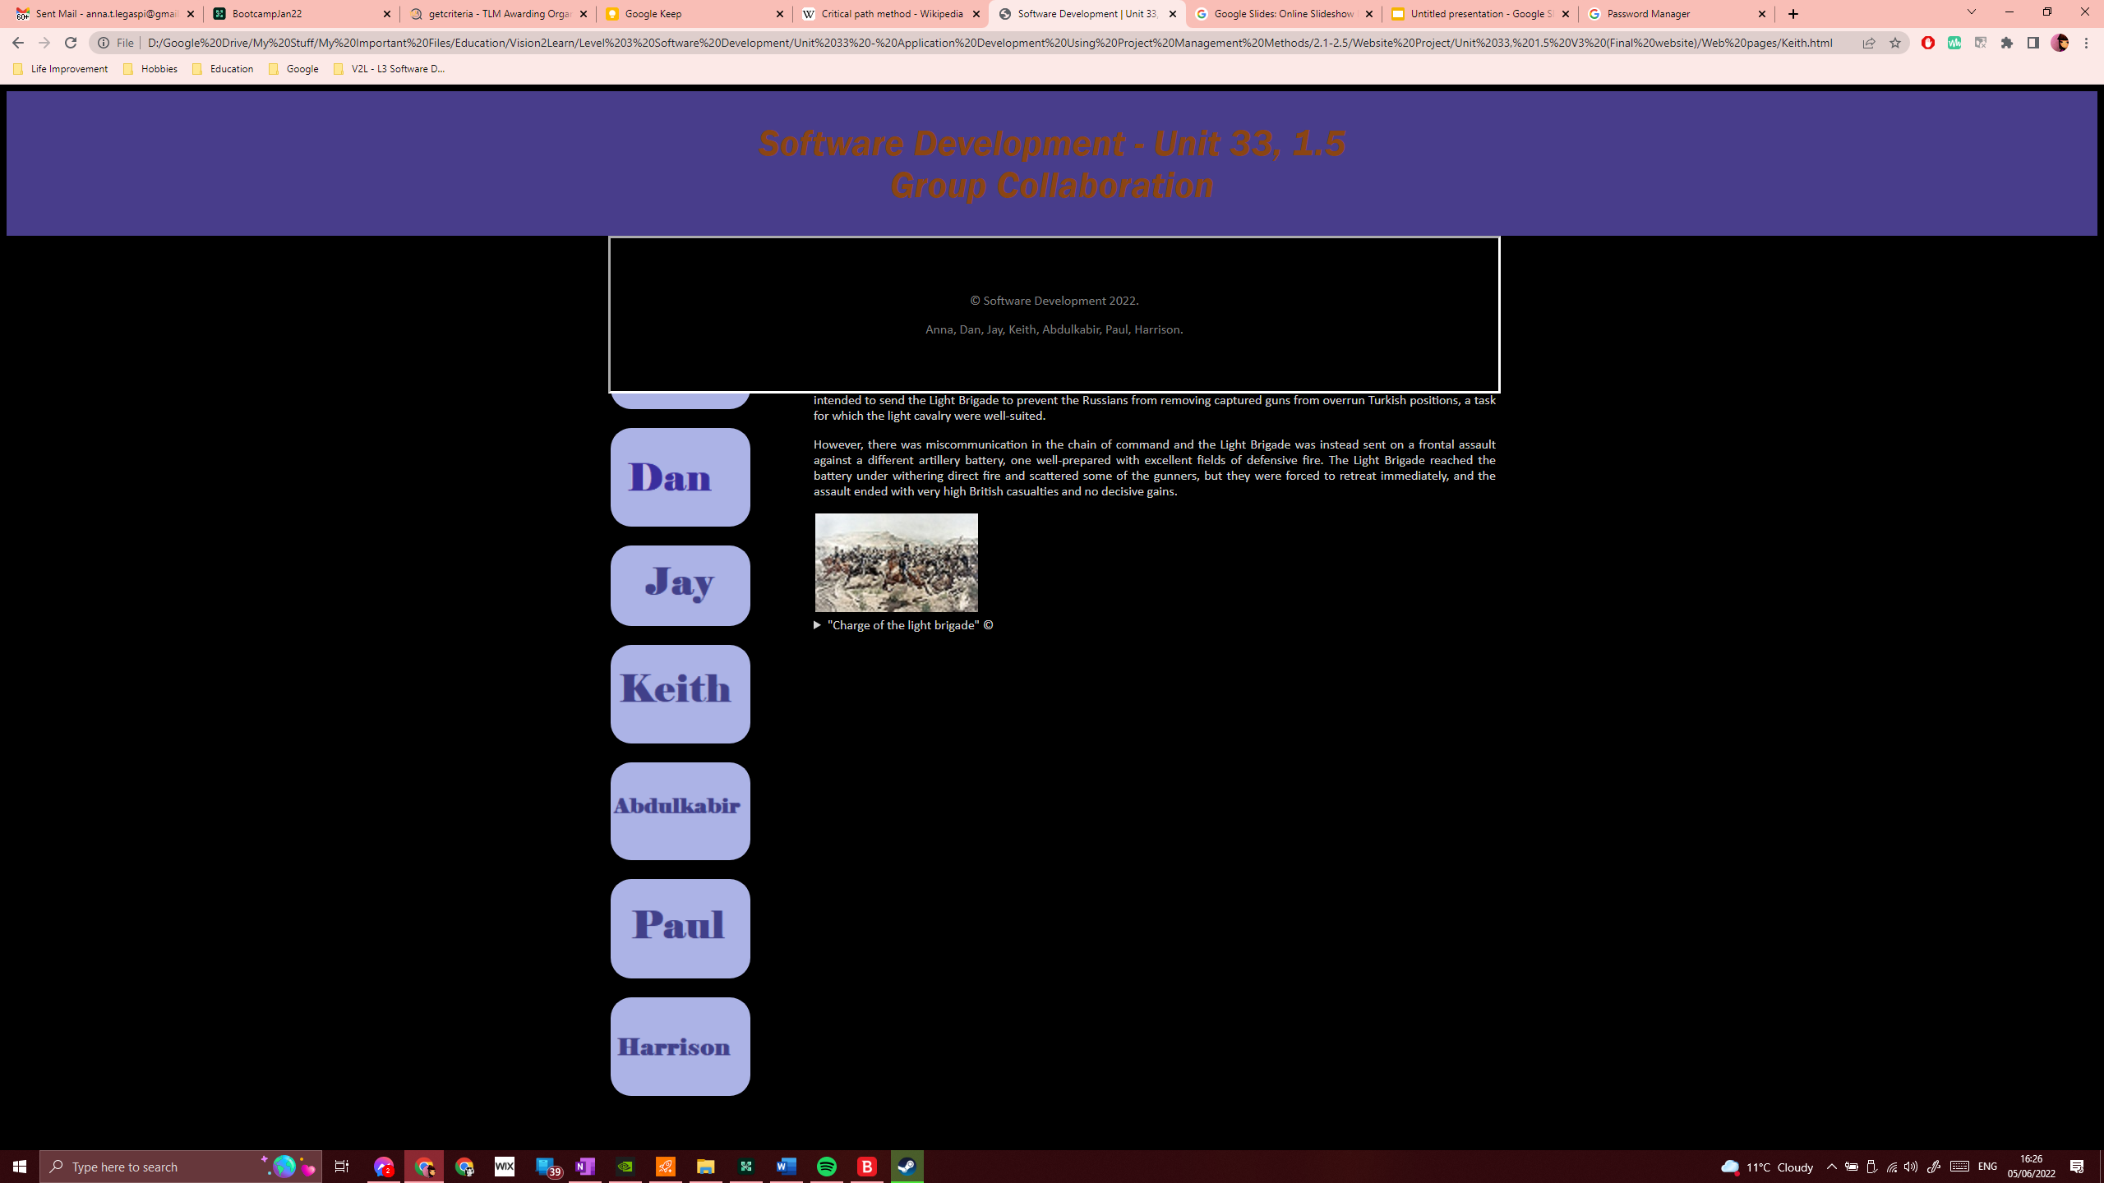

Figure 4 Keith's page

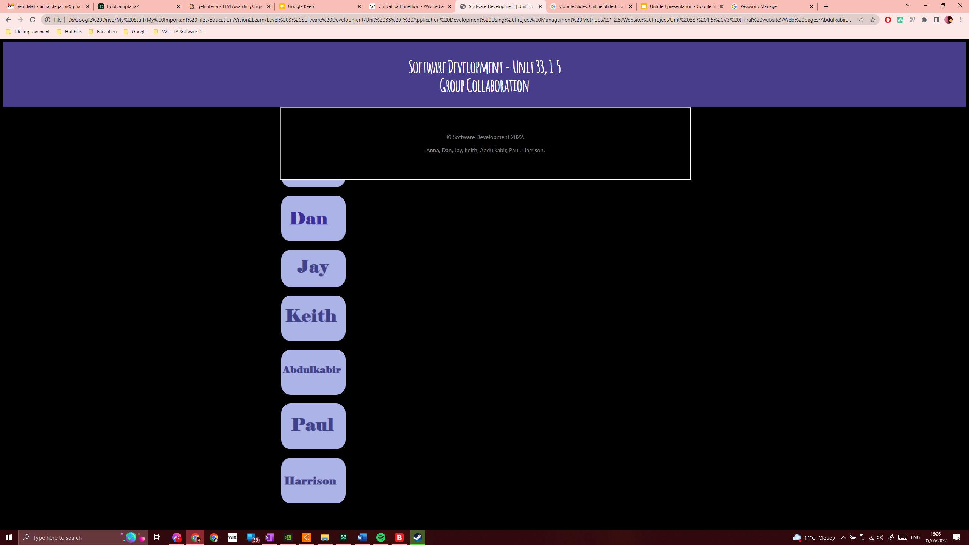

Figure 5 Abdulkabir's page

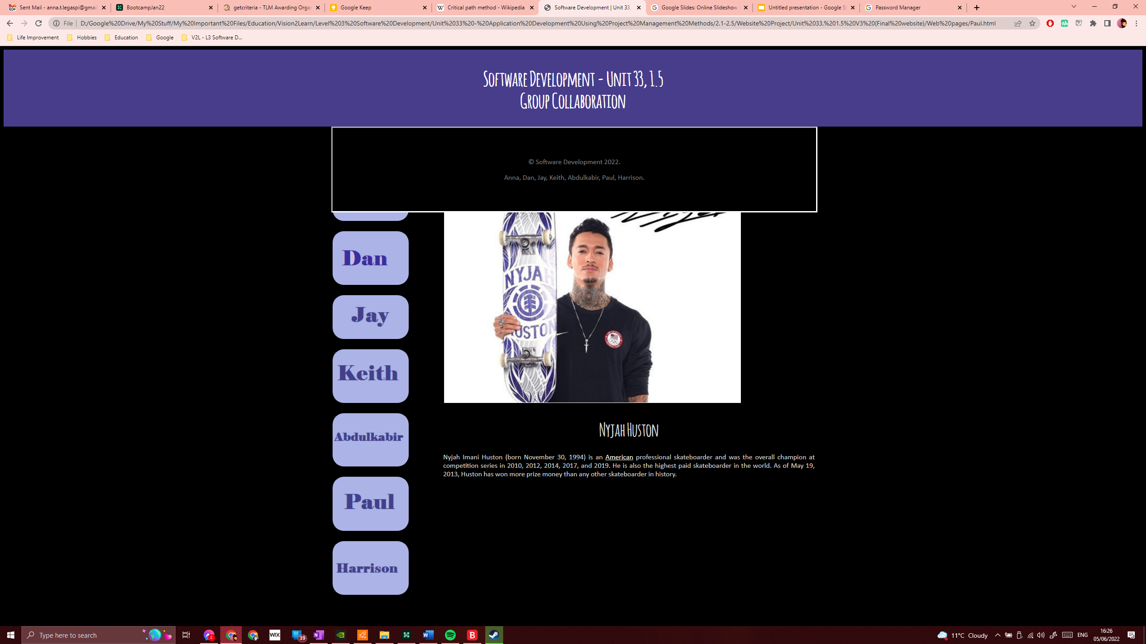

Figure 6 Paul's page



Figure 7 Harrison's page